Apartments for Rent $1,025*
Call (202) 582-2535 Now!
1, 2, &3-Bedroom Apartments as low as $1,025 per month*
( *plus utilities, prices subject to change & may vary by unit and size.)
OASIS REALTY SERVICE presents:
"MINNESOTA TERRACE APARTMENTS",
Where 'Good People' Stay!
Dear Future Tenant:
Well Managed and Affordable Rental Apartments are sometimes difficult to find unless you first come and see "Minnesota Terrace Apartments". Here you will find a caring community of Washington D.C. residents that share a commitment to follow our fair rules and enjoy the relative peace and beauty and other benefits of the Fort Dupont Park neighborhood of our Nation's Capitol.
Conveniently located near Golfing, Shopping, and Entertainment and Sports Centers and Medical Facilities. We have plenty of Off-Street Parking and MetroBus and MetroRail Subway routes are nearby for your easy travel needs. Lovely Fort Dupont Park is only a short walk or bike ride away.
We offer "Garden Style" walk-up apartment living with secure doors and well landscaped grounds that add beauty to our buildings which are fenced and also guarded by natural barriers for your privacy.
Please come visit and pick up an application: 301 Anacostia Rd., S.E. #101, Wash. DC 20019
Minnesota Terrace Apartments, Directions:
Free Parking in our private lot off 36th St. S.E.
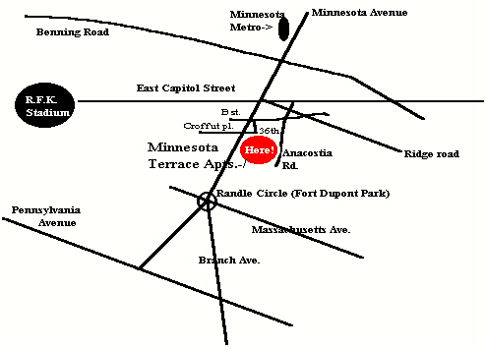
Enter from Minnesota Avenue into our Parking Lot off 36th St and B St. and Croffut place. Call 202-582-2535.
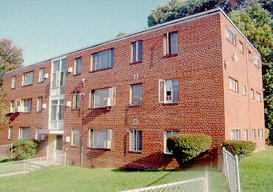
Please visit us at: 301 Anacostia Rd., S.E. #101, Wash. DC 20019 to see your future home and pick up an application.
You can download applications from our Website: http://www.RentOasis.com
You can E-mail us at
Oasis_Realty@Yahoo.com
Also: TopAgent@WriteMe.com

How to Apply:
1 | Schedule a visit by Calling (202) 582-2535
2 | Pick up an application in person, by mail or internet
3   | Read copy of rules and regulations and application
4 | Return Filled out application with application fee.
5 | That's It! We will contact you with our decision A.S.A.P.

